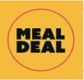

Meal Deal

Choose from a

Pasta Pot or a

Jacket Potato with a Filling
add a

Homemade Tray Bake or Cookie or a Fruit Pot

£2.75

Look out for the meal Deal Stickers

